EXPT NO:2 | LOAD AND VISUALIZE A DATASET USING TABLEAU and PowerBI
DATE: 10.07.2026

Name: Akhil C

Roll no: 24BAD007

PRE-LAB QUESTIONS (PROVIDE BRIEF ANSWERS TO THE FOLLOWING QUESTIONS)
- Why is Tableau a preferred tool for data visualization?
Tableau is preferred because it provides interactive visualizations, an easy drag-and-drop interface, and supports fast data analysis from multiple data sources

- What is the primary use of a line chart in data analysis?
A line chart is used to visualize trends and changes in data over time

- When would you use a tree map instead of a bar chart?
A tree map is used when displaying hierarchical data and comparing the proportion of categories within a limited space.

- What is the significance of filters in Tableau visualizations?
Filters allow users to display only relevant data, making analysis more focused and interactive.

- How does Tableau handle geographic data for visualizations?
Tableau automatically recognizes geographic fields such as Country, State, and City and plots them on maps using latitude and longitude.

IN-LAB EXERCISE:
OBJECTIVE:
To load a dataset into Tableau, create a variety of visualizations, and derive insights from the data using different chart types available in Tableau.

PROCEDURE:

Dataset Selection:
Use the Global Superstore Sales Dataset (available on Kaggle or Tableau's sample datasets).
Ensure the dataset includes fields like Order Date, Category, Region, Sales, Profit, and Customer Segment.

Data Loading:
Open Tableau and connect to the dataset.
Review the dataset structure, field data types, and missing values.
Chart Creations (Step-by-Step):
- Bar Chart:
Objective: Compare total sales by region and category.
Plot Region on the x-axis and Sales on the y-axis. Add Category as a color dimension.

Line Chart:
Objective: Visualize sales trends over time.
Place Order Date on the x-axis and Sales on the y-axis. Set granularity to Month and color by Category.

Pie Chart:
Objective: Show sales distribution by product category.
Assign Category as the dimension and Sales as the measure.

Scatter Plot:
Objective: Examine the relationship between profit and sales.
Plot Profit on the x-axis and Sales on the y-axis.

Use Sub-Category as the color dimension.

Heatmap:
Objective: Compare sales across categories and regions.
Use Region and Category as dimensions.
Use Sales as the measure and apply color coding.

Geographical Map:
Objective: Visualize total sales by country.
Set Country as the geographical field.
Use Sales to define size and color gradients.

Tree Map:
Objective: Display sales distribution by category and sub-category. Use Category and Sub-Category as dimensions, and Sales as the measure. Customization and Interactivity:
Add filters to explore data subsets interactively (e.g., by year, region, or category). Include annotations, labels, and formatting for clarity.

Dashboard Creation:
Combine all charts into a single dashboard to present a cohesive story. Add interactive filters and tooltips for dynamic exploration.

Experiment Dataset:
Global Superstore Sales Dataset
Source: https://www.kaggle.com/datasets/apoorvaappz/global-super-store-dataset

Fields Used:
Order Date Region Category
Sub-Category Sales
Profit
Country

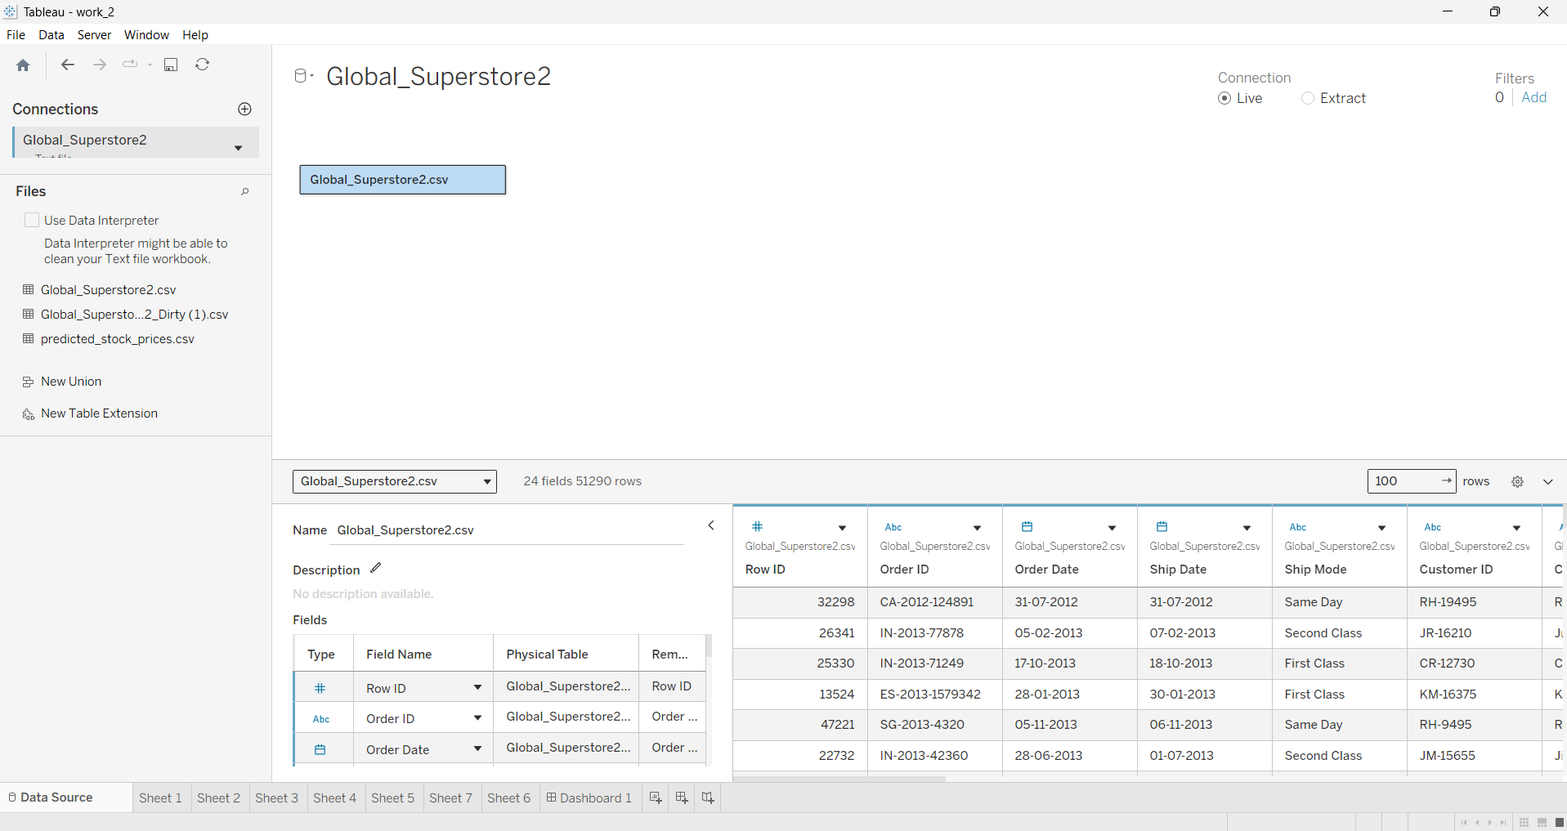
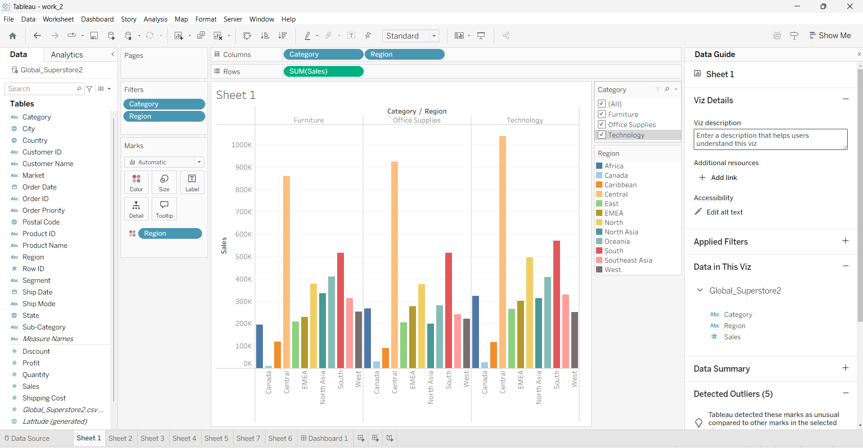
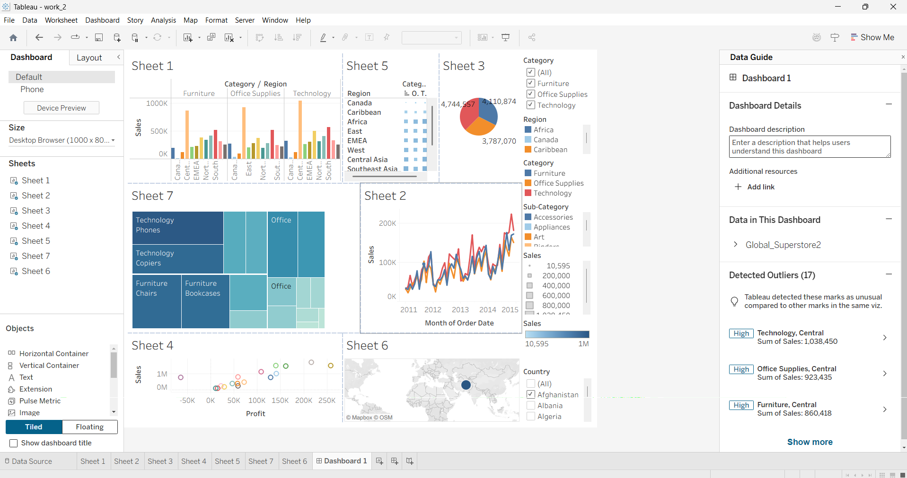

POST-LAB QUESTIONS (PROVIDE BRIEF ANSWERS TO THE FOLLOWING QUESTIONS)

Bar Chart:
What regions had the highest and lowest total sales?

How does the performance of categories vary across regions?

The Central region recorded the highest sales, while the Cannada region had the lowest sales.
Technology generated the highest sales in most regions, while Office Supplies generally contributed the least.

Line Chart:
Identify the month with peak sales.
Which category shows consistent growth in sales over time?
November 2015 recorded the highest sales
The Technology category showed the most consistent growth

Pie Chart:
Which category contributes the most to overall sales?
Are there any categories with negligible sales contributions?
Technology contributed the highest share of total sales.
No. All categories contributed significantly, although furniture Supplies had the smallest share.

Scatter Plot:
Is there a noticeable correlation between profit and sales? Which sub-category shows the highest sales but low profit?
Yes. There is a positive correlation where higher sales generally result in higher profit.
Tables showed relatively high sales but comparatively low profit.
Heatmap:
Which region-category combination has the highest sales?
Identify any regions with poor sales performance across all categories.
The Central region's Technology category had the highest sales.
The Central highest total sales.

Geographical Map:
Which country has the highest total sales? Are there regions with minimal or no sales?
Some countries or regions had comparatively low sales, but no major region had zero sales.
Phones, Chairs, and Storage were among the highest-selling sub-categories
Tree Map:
Which sub-category dominates the sales in each category? Are there any sub-categories with unexpectedly low sales?
Fastners and Labels recorded relatively low sales.

Dashboard:
What insights can you derive when combining all visualizations? How do filters enhance the utility of the dashboard?
The dashboard helps identify sales trends, regional performance, category-wise contributions, profit relationships, and overall business performance in one place.
Filters allow users to analyze specific regions, categories, years, or products interactively, making the dashboard more flexible and informative.

ASSESSMENT

Description | Max Marks | Marks Awarded
Pre Lab Exercise | 5
In Lab Exercise | 10
Post Lab Exercise | 5
Viva | 10
Total | 30
Faculty Signature

